Name:_______________________________ Period: ___

It’s a Wonderful Life Analysis
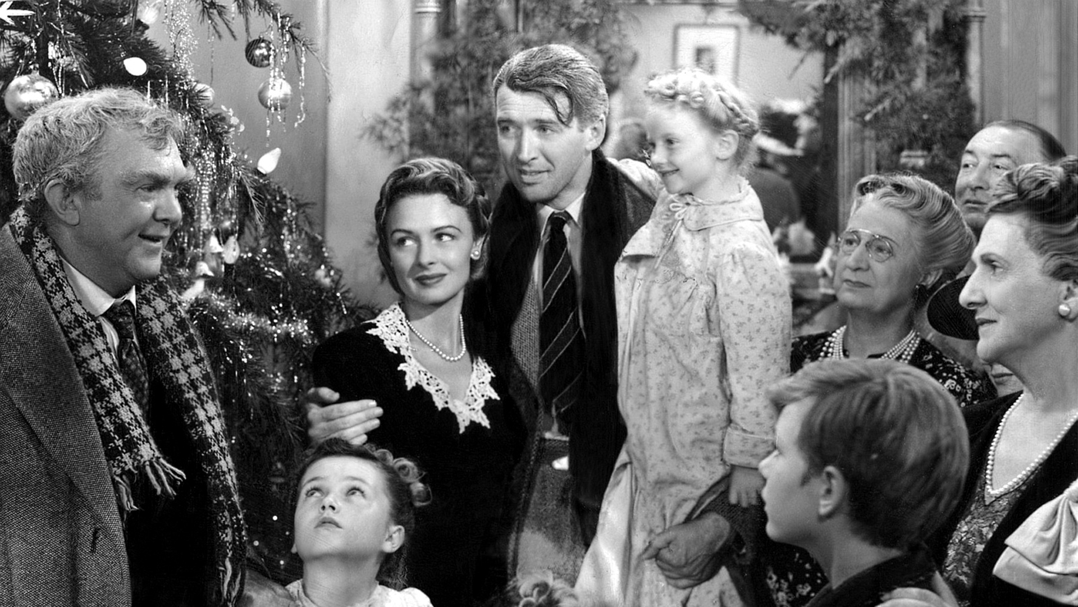

Name: George Bailey
Wants/Goals/Objective: _____________________________________________
________________________________________________________________________________________________________________________________
Personal Conflicts:_________________________________________________
________________________________________________________________
________________________________________________________________

Name: Mary Hatch/Bailey
Wants/Goals/Objective: _____________________________________________
________________________________________________________________________________________________________________________________
Personal Conflicts:_________________________________________________
________________________________________________________________
________________________________________________________________

Name: Uncle Billy
Wants/Goals/Objective: _____________________________________________
________________________________________________________________________________________________________________________________
Personal Conflicts:_________________________________________________
________________________________________________________________
________________________________________________________________

Name: Mr. Potter
Wants/Goals/Objective: _____________________________________________
________________________________________________________________________________________________________________________________
Personal Conflicts:_________________________________________________
________________________________________________________________
________________________________________________________________

Name: Sam Wainwright
Wants/Goals/Objective: _____________________________________________
________________________________________________________________________________________________________________________________
Personal Conflicts:_________________________________________________
________________________________________________________________
________________________________________________________________
Name: Clarence
Wants/Goals/Objective: _____________________________________________
________________________________________________________________________________________________________________________________
Personal Conflicts:_________________________________________________
________________________________________________________________
________________________________________________________________

What is the major conflict in the story?
________________________________________________________________________________________________________________________________________________________________________________________________________________________________________________________________

How does this conflict get resolved?
________________________________________________________________________________________________________________________________________________________________________________________________________________________________________________________________

Explain which character you liked the most and explain why.
________________________________________________________________________________________________________________________________________________________________________________________________________________________________________________________________

Which scene was the most memorable to you?
________________________________________________________________________________________________________________________________________________________________________________________________________________________________________________________________

What message does this story teach?
________________________________________________________________________________________________________________________________________________________________________________________________________________________________________________________________
________________________________________________________________________________________________________________________________________________________________________________________________________________________________________________________________
________________________________________________________________________________________________________________________________________________________________________________________________________________________________________________________________

